CAMO Community Oncology Bursary | 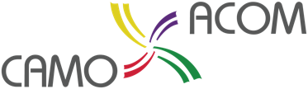  2025 Application Form
Submission deadline
Rotations taking place between January & June |Application deadline: July 31, 2024
Rotations taking place between July & December | Application deadline: December 2, 2024

Resident Information
First Name: |  | Last Name:
Mailing address:
City: | Province: |  | Postal Code:
Tel: |  | Email:

Resident Status
PGY4 | PGY5 | Institution:
Supervisor name: |  |  | Supervisor email:

Community Rotation
Location of rotation:
Start date: | End date:
What do you expect to gain with this opportunity:

How will this influence your career:

Document Checklist
Letter of support for rotation & approval by supervisor
1-page proposal
Resident CV
Are you a CAMO member | Yes | No
Is your supervisor a CAMO member | Yes | No

Disclaimer and Signature
I hereby understand and agree that any bursaries made as a result of this application will be subject to the CAMO terms and conditions.
Signature of resident | Date
Signature of program director | Date
Signature of supervisor | Date

